Task1
let itemPrice = 450.0
let quantity = 3
let subtotal = itemPrice * Double(quantity)
let hasCoupon = true
let discount = (hasCoupon && subtotal > 1000) ? subtotal * 0.10 : 0.0
let gst = (subtotal - discount) * 0.18
let total = subtotal - discount + gst
let share = total / 4.0
print("Each person's share: ₹\(share)")
let amount = 1234
print("Hundreds: \(amount / 100)")
print("Remainder: \(amount % 100)")
output
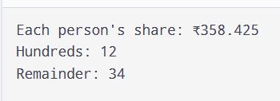
Task2
let year = 1900
let isLeapYear = (year % 4 == 0 && year % 100 != 0) || year % 400 == 0
print(isLeapYear)
print((2000 % 4 == 0 && 2000 % 100 != 0) || 2000 % 400 == 0)
print((2024 % 4 == 0 && 2024 % 100 != 0) || 2024 % 400 == 0)
print((2026 % 4 == 0 && 2026 % 100 != 0) || 2026 % 400 == 0)
let number = 50
let isInRange = (1...100).contains(number)
let isEvenNotMultipleOf10 = number % 2 == 0 && number % 10 != 0
let nickname: String? = nil
print(nickname ?? "Guest")
output
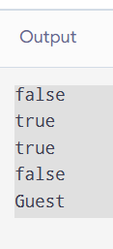
Task3

print(7 / 2)
print(7 % 2)
print(-7 % 3)
print(7.0 / 2)
print(10 - 2 * 3 + 4 / 2)
print(5 > 3 && 2 > 4 || true)
print(1 << 3)
print(6 & 3, 6 | 3, 6 ^ 3)
let x: UInt8 = 255
print(x &+ 1)
output:
